Sprained Ankle

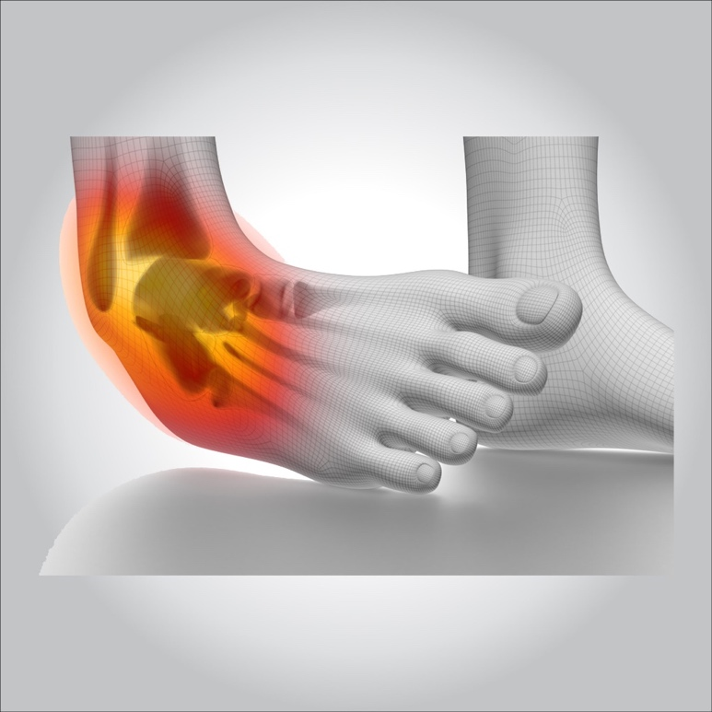

**A sprained ankle is an injury that occurs when you roll, twist or turn your ankle in an awkward way. This can stretch or tear the tough bands of tissue (ligaments) that help hold your ankle bones together.**

**Ligaments help stabilize joints, preventing excessive movement. A sprained ankle occurs when the ligaments are forced beyond their normal range of motion. Most sprained ankles involve injuries to the ligaments on the outer side of the ankle.**

**Treatment for a sprained ankle depends on the severity of the injury. Although self-care measures and over-the-counter pain medications may be all you need, a medical evaluation might be necessary to reveal how badly you’ve sprained your ankle and to determine the appropriate treatment.**

**Symptoms**

**Signs and symptoms of a sprained ankle vary depending on the severity of the injury. They may include:**

* **Pain, especially when you bear weight on the affected foot**
* **Tenderness when you touch the ankle**
* **Swelling**
* **Bruising**
* **Restricted range of motion**
* **Instability in the ankle**
* **Popping sensation or sound at the time of injury**



**Treatment**

**Treatment for a sprained ankle depends on the severity of your injury. The treatment goals are to reduce pain and swelling, promote healing of the ligament, and restore function of the ankle. For severe injuries, you may be referred to a specialist in musculoskeletal injuries, such as an orthopedic surgeon or a physician specializing in physical medicine and rehabilitation.**

**Self-care**

**For self-care of an ankle sprain, use the R.I.C.E. approach for the first two or three days:**

* **Rest. Avoid activities that cause pain, swelling or discomfort.**
* **Ice. Use an ice pack or ice slush bath immediately for 15 to 20 minutes and repeat every two to three hours while you’re awake. If you have vascular disease, diabetes or decreased sensation, talk with your doctor before applying ice.**
* **Compression. To help stop swelling, compress the ankle with an elastic bandage until the swelling stops. Don’t hinder circulation by wrapping too tightly. Begin wrapping at the end farthest from your heart.**
* **Elevation. To reduce swelling, elevate your ankle above the level of your heart, especially at night. Gravity helps reduce swelling by draining excess fluid.**

**Medications**

**In most cases, over-the-counter pain relievers — such as ibuprofen (Advil, Motrin IB, others) or naproxen sodium (Aleve, others) or acetaminophen (Tylenol, others) — are enough to manage the pain of a sprained ankle.**

**Devices**

**Because walking with a sprained ankle might be painful, you may need to use crutches until the pain subsides. Depending on the severity of the sprain, your doctor may recommend an elastic bandage, sports tape or an ankle support brace to stabilize the ankle. In the case of a severe sprain, a cast or walking boot may be necessary to immobilize the ankle while the tendon heals.**

**Therapy**

**Once the swelling and pain is lessened enough to resume movement, your doctor will ask you to begin a series of exercises to restore your ankle’s range of motion, strength, flexibility and stability. Your doctor or a physical therapist will explain the appropriate method and progression of exercises.**

**Balance and stability training is especially important to retrain the ankle muscles to work together to support the joint and to help prevent recurrent sprains. These exercises may involve various degrees of balance challenge, such as standing on one leg.**

**If you sprained your ankle while exercising or participating in a sport, talk to your doctor about when you can resume your activity. Your doctor or physical therapist may want you to perform particular activity and movement tests to determine how well your ankle functions for the sports you play.**

**Surgery**

**In rare cases, surgery is performed when the injury doesn’t heal or the ankle remains unstable after a long period of physical therapy and rehabilitative exercise. Surgery may be performed to:**

* **Repair a ligament that won’t heal**
* **Reconstruct a ligament with tissue from a nearby ligament or tendon**